UNIT 5
Networks-Business process Re-Engineering –Data ware House:Architecture to Implementation- Electronic Business Technlogy.
Networks
Data Sharing and Communication:
Networks enable the sharing of data and information among different departments, branches, and users within an organization.
Through networked systems such as intranets, employees can access centralized databases, documents, and applications, allowing for efficient collaboration and communication across the organization.
Centralized Data Storage:
Networks provide a platform for centralized data storage, where information from various sources is stored in databases or servers accessible to authorized users.
Centralized data storage facilitates data consistency, integrity, and security, ensuring that users have access to accurate and up-to-date information for decision-making and analysis.
Resource Sharing:
Networks allow for the sharing of hardware resources such as printers, scanners, and storage devices across multiple users and departments.
By connecting these resources to the network, organizations can optimize resource utilization, reduce costs, and improve efficiency in resource management.
Remote Access:
Networks enable remote access to MIS systems and resources, allowing users to access information and applications from any location with internet connectivity.
Remote access capabilities enhance flexibility, productivity, and accessibility for employees who work remotely or need to access MIS systems while on the go.
Security and Access Control:
Network security measures such as firewalls, encryption, and access controls are implemented to protect MIS systems and data from unauthorized access, intrusion, and cyber threats.
Access controls ensure that only authorized users have access to sensitive information and resources, safeguarding the integrity and confidentiality of data stored in MIS systems.
Integration with External Systems:
Networks facilitate integration with external systems, such as suppliers, customers, partners, and vendors, through extranets and electronic data interchange (EDI) systems.
Integration with external systems streamlines business processes, enhances supply chain management, and enables seamless communication and data exchange with external stakeholders.
Disaster Recovery and Backup:
Networks support disaster recovery and backup strategies by replicating data and applications across multiple servers or locations.
Redundant network configurations and backup systems ensure business continuity and minimize downtime in the event of system failures, natural disasters, or cyber attacks.
Business process Re-Engineering
Analysis of Current Processes:
BPR begins with a comprehensive analysis of existing business processes within the organization.
This involves identifying inefficiencies, redundancies, bottlenecks, and areas for improvement in how information flows and tasks are performed.
Alignment with Organizational Goals:
BPR initiatives must align with the strategic goals and objectives of the organization.
This involves identifying key performance indicators (KPIs) and desired outcomes that the re-engineered processes aim to achieve.
Identification of Technology Solutions:
MIS professionals work closely with business stakeholders to identify and evaluate technology solutions that can support process re-engineering efforts.
This may involve implementing new software applications, upgrading existing systems, or adopting emerging technologies such as cloud computing, big data analytics, or robotic process automation (RPA).
Process Redesign and Optimization:

Based on the analysis of current processes and technology capabilities, MIS professionals redesign and optimize business processes to improve efficiency, effectiveness, and agility.
This may involve simplifying workflows, eliminating unnecessary steps, automating repetitive tasks, and integrating systems for seamless information flow.
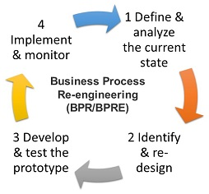

Implementation of Technology Solutions:
Once the redesigned processes are finalized, MIS teams oversee the implementation of technology solutions to support these processes.
This may involve configuring software systems, developing custom applications, training users, and ensuring smooth transition from old to new processes.
Change Management and Training:
BPR initiatives require effective change management to ensure buy-in and adoption from employees at all levels of the organization.
MIS professionals develop training programs, communication strategies, and support mechanisms to help employees understand and adapt to the new processes and technologies.

Monitoring and Continuous Improvement:
After the implementation of re-engineered processes, MIS teams monitor performance metrics and gather feedback to assess the effectiveness of changes.
Continuous improvement efforts involve iterating on the redesigned processes, addressing any issues or challenges that arise, and making further enhancements to optimize performance.
Integration with MIS Systems:
Throughout the BPR process, MIS professionals ensure that re-engineered processes are seamlessly integrated with existing MIS systems and databases.
This involves data migration, system integration, and interoperability testing to ensure that information flows smoothly and accurately across the organization.

Data ware House:Architecture to Implementation
Requirements Gathering:
The first step is to gather requirements from stakeholders across the organization to understand their data needs, reporting requirements, and business objectives.
Determine the types of data to be stored in the data warehouse, including structured, semi-structured, and unstructured data sources.
Data Modeling:
Develop a conceptual data model that represents the high-level structure of the data warehouse, including entities, attributes, and relationships.
Translate the conceptual model into a logical data model, defining tables, columns, keys, and relationships based on the specific requirements gathered.
Selecting Technologies:
Evaluate and select appropriate technologies and tools for building and managing the data warehouse.
Consider factors such as scalability, performance, data integration capabilities, security features, and compatibility with existing systems.
Designing the Architecture:
Define the architecture of the data warehouse, including the physical storage, data integration processes, and analytical components.
Determine whether to use a traditional relational database model, a distributed data warehouse architecture, or a cloud-based data warehouse solution.
Data Extraction, Transformation, and Loading (ETL):
Develop ETL processes to extract data from source systems, transform it into a consistent format, and load it into the data warehouse.
Implement data cleansing, deduplication, normalization, and aggregation techniques to ensure data quality and consistency.
Building Dimensional Models:
Design dimensional models for organizing and structuring data within the data warehouse, including fact tables, dimension tables, and star or snowflake schemas.
Define hierarchies, attributes, and relationships within dimensional models to support analytical queries and reporting.
Indexing and Optimization:
Implement indexing and optimization techniques to improve query performance and reduce latency in data retrieval.
Create indexes on frequently queried columns, optimize SQL queries, and partition large tables for efficient data access.
Security and Access Control:
Implement security measures to protect sensitive data stored in the data warehouse.
Define access controls, user roles, and permissions to ensure that only authorized users can access and manipulate data.
Metadata Management:
Establish metadata management processes to document and catalog data assets within the data warehouse.
Maintain metadata repositories containing information about data sources, data definitions, transformation rules, and lineage.
Testing and Quality Assurance:
Conduct rigorous testing of the data warehouse to validate data integrity, accuracy, and performance.
Perform end-to-end testing of ETL processes, data integration workflows, and analytical queries to identify and resolve any issues.
Deployment and Rollout:
Deploy the data warehouse to production environments and ensure that it is properly configured and integrated with other systems.
Develop rollout plans and training materials to educate users and stakeholders on how to use the data warehouse effectively.
Monitoring and Maintenance:
Establish monitoring and maintenance procedures to ensure the ongoing health and performance of the data warehouse.
Monitor system performance, data loads, and query execution times, and perform regular maintenance tasks such as data backups, index rebuilds, and software updates.

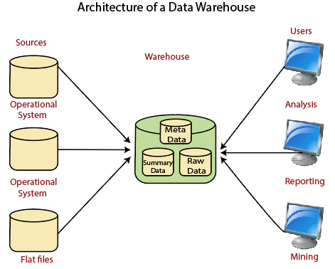
Electronic Business Technlogy
E-commerce Platforms:
E-commerce platforms enable organizations to sell products and services online to customers around the world.
MIS systems support the development, implementation, and management of e-commerce websites, including online storefronts, product catalogs, shopping carts, and payment gateways.
Integration with backend systems such as inventory management, order processing, and customer relationship management (CRM) systems ensures seamless transactions and order fulfillment.
Online Marketplaces:
Online marketplaces provide a platform for businesses to buy and sell products and services with other businesses or consumers.
MIS systems facilitate the integration of organizations with online marketplaces, enabling them to list products, manage orders, and fulfill transactions efficiently.
Integration with supply chain management (SCM) systems and logistics partners streamlines order processing, inventory management, and shipping processes.
Electronic Payment Systems:
Electronic payment systems enable secure and convenient online transactions, allowing customers to pay for goods and services electronically.
MIS systems support the integration of various payment methods, including credit cards, debit cards, digital wallets, and mobile payment solutions.
Security measures such as encryption, tokenization, and fraud detection mechanisms are implemented to protect sensitive payment information and ensure transaction security.
Supply Chain Management (SCM):
SCM systems facilitate the management of the end-to-end supply chain process, from procurement and production to distribution and logistics.
E-business technologies enable real-time visibility into supply chain operations, collaboration with suppliers and partners, and optimization of inventory levels and order fulfillment processes.
Integration with enterprise resource planning (ERP) systems, transportation management systems (TMS), and warehouse management systems (WMS) enhances coordination and efficiency in supply chain operations.

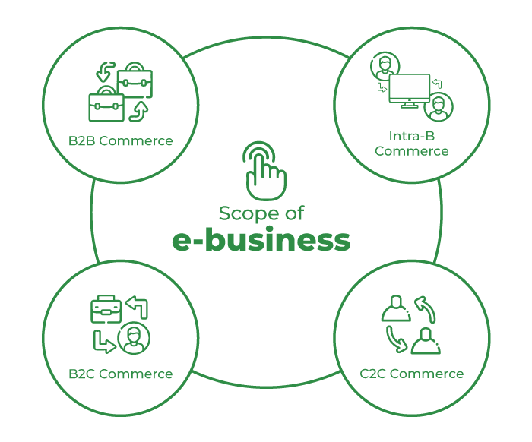

Customer Relationship Management (CRM):
CRM systems enable organizations to manage interactions with customers, track customer preferences and behaviors, and provide personalized services.
E-business technologies support the integration of CRM systems with online channels such as websites, email, social media, and mobile apps, enabling organizations to deliver seamless omni-channel experiences.
Customer data collected through e-business channels is analyzed to identify trends, segment customers, and tailor marketing campaigns and promotional offers.

Digital Marketing and Analytics:
E-business technologies support digital marketing initiatives such as search engine optimization (SEO), social media marketing, email marketing, and content marketing.
MIS systems provide tools for tracking and analyzing digital marketing metrics, such as website traffic, conversion rates, click-through rates, and return on investment (ROI).
Data analytics capabilities enable organizations to gain insights into customer behavior, preferences, and trends, informing marketing strategies and decision-making processes.
Cloud Computing and SaaS Solutions:
Cloud computing and software-as-a-service (SaaS) solutions provide flexible and scalable platforms for deploying and managing e-business applications and services.
MIS systems leverage cloud-based technologies to reduce infrastructure costs, increase agility, and support rapid innovation and experimentation.
Cloud-based e-business solutions offer benefits such as accessibility, scalability, reliability, and security, enabling organizations to focus on their core business activities.

